Experiment 9: Design and Simulation of Parallel
Computing Architectures Using the Multi2Sim Simulator
Aaron Gomes
UID: 2025300073
1. Aim:
To design and simulate parallel computing architectures (single-core, multicore, multithreaded and
networked) using the Multi2Sim simulator, and to record cycles and IPC for each design.

Code:

Matmul.c:
#include <stdio.h>
#define N 32
int A[N][N], B[N][N], C[N][N];
int main() {
int i, j, k;
for (i = 0; i < N; i++)
for (j = 0; j < N; j++) { A[i][j] = 1; B[i][j] = 2; C[i][j] = 0; }
for (i = 0; i < N; i++)
for (j = 0; j < N; j++)
for (k = 0; k < N; k++)
C[i][j] += A[i][k] * B[k][j];
printf("Done: %d\n", C[0][0]);
return 0;
}

X86_1.cfg:
[ General ]
Cores = 1
Threads = 1

Output:
mint@mint:~$ sudo apt install docker.io
[sudo] password for mint:
Reading package lists... Done
Building dependency tree... Done
Reading state information... Done
The following additional packages will be installed:
containerd pigz runc ubuntu-fan
Suggested packages:
aufs-tools cgroupfs-mount | cgroup-lite docker-buildx docker-compose-v2
docker-doc rinse zfs-fuse | zfsutils
The following NEW packages will be installed:
containerd docker.io pigz runc ubuntu-fan
0 upgraded, 5 newly installed, 0 to remove and 3 not upgraded.
Need to get 73.4 MB of archives.
After this operation, 278 MB of additional disk space will be used.
Do you want to continue? [Y/n] y
Get:1 http://archive.ubuntu.com/ubuntu noble/universe amd64 pigz amd64 2.8-1 [65.6 kB]
Get:2 http://archive.ubuntu.com/ubuntu noble-updates/main amd64 runc amd64 1.3.4-0ubuntu1~24.04.1 [9,574 kB]
Get:3 http://archive.ubuntu.com/ubuntu noble-updates/main amd64 containerd amd64 2.2.1-0ubuntu1~24.04.3 [28.1 MB]
Get:4 http://archive.ubuntu.com/ubuntu noble-updates/universe amd64 docker.io amd64 29.1.3-0ubuntu3~24.04.2 [35.6 MB]
Get:5 http://archive.ubuntu.com/ubuntu noble-updates/universe amd64 ubuntu-fan all 0.12.16+24.04.1 [34.2 kB]
Fetched 73.4 MB in 23s (3,233 kB/s)
Preconfiguring packages ...
Selecting previously unselected package pigz.
(Reading database… 571212 files and directories currently installed.)
Preparing to unpack …/archives/pigz_2.8-1_amd64.deb…
Unpacking pigz (2.8-1)…
Selecting previously unselected package runc.
Preparing to unpack …/runc_1.3.4-0ubuntu1~24.04.1_amd64.deb…
Unpacking runc (1.3.4-0ubuntu1~24.04.1)…
Selecting previously unselected package containerd.
Preparing to unpack …/containerd_2.2.1-0ubuntu1~24.04.3_amd64.deb…
Unpacking containerd (2.2.1-0ubuntu1~24.04.3)…
Selecting previously unselected package docker.io.
Preparing to unpack …/docker.io_29.1.3-0ubuntu3~24.04.2_amd64.deb…
Unpacking docker.io (29.1.3-0ubuntu3~24.04.2)…
Selecting previously unselected package ubuntu-fan.
Preparing to unpack …/ubuntu-fan_0.12.16+24.04.1_all.deb…
Unpacking ubuntu-fan (0.12.16+24.04.1)…
Setting up ubuntu-fan (0.12.16+24.04.1)…
Created symlink /etc/systemd/system/multi-user.target.wants/ubuntu-fan.service →
/usr/lib/systemd/system/ubuntu-fan.service.
Setting up runc (1.3.4-0ubuntu1~24.04.1)…
Setting up pigz (2.8-1)…
Setting up containerd (2.2.1-0ubuntu1~24.04.3)…
Created symlink /etc/systemd/system/multi-user.target.wants/containerd.service →
/usr/lib/systemd/system/containerd.service.
Setting up docker.io (29.1.3-0ubuntu3~24.04.2)…
info: Selecting GID from range 100 to 999 ...
info: Adding group `docker' (GID 130) ...
Created symlink /etc/systemd/system/multi-user.target.wants/docker.service → /us
r/lib/systemd/system/docker.service.
Created symlink /etc/systemd/system/sockets.target.wants/docker.socket → /usr/li
b/systemd/system/docker.socket.
Processing triggers for man-db (2.12.0-4build2)…
mint@mint:~$ docker pull multi2sim/multi2sim
Using default tag: latest
permission denied while trying to connect to the docker API at unix:///var/run/docker.sock
mint@mint:~$ sudo !!
sudo sudo apt install docker.io
Reading package lists... Done
Building dependency tree... Done
Reading state information... Done
docker.io is already the newest version (29.1.3-0ubuntu3~24.04.2).
0 upgraded, 0 newly installed, 0 to remove and 3 not upgraded.
mint@mint:~$ sudo docker pull multi2sim/multi2sim
Using default tag: latest
latest: Pulling from multi2sim/multi2sim
6b3484221732: Pull complete
04c996abc244: Pull complete
d394d3da86fe: Pull complete
b48b86b78e97: Pull complete
bac77aae22d4: Pull complete
e572a7014564: Pull complete
c960fa85324a: Pull complete
09b3dd842bf5: Pull complete
Digest: sha256:5b2948c6c20d8ae817253fab50ceec4d5fa2b7b4b16894feb3feaa2fdbf81dbb
Status: Downloaded newer image for multi2sim/multi2sim:latest
docker.io/multi2sim/multi2sim:latest
mint@mint:~$ mkdir ~/m2s_lab && cd ~/m2s_lab
mint@mint:~/m2s_lab$ sudo docker run -it -v $(pwd):/workspace multi2sim/multi2sim bash
root@c8f18c19505c:/# ls
bin dev home lib32 libx32 mnt proc run srv tmp var
boot etc lib lib64 media opt root sbin sys usr workspace
root@c8f18c19505c:/# cd workspace/
root@c8f18c19505c:/workspace# ls
gen_mem.sh matmul.c
root@c8f18c19505c:/workspace# gcc -m32 -static -O0 matmul.c -o matmul
root@c8f18c19505c:/workspace# m2s --x86-sim functional ./matmul

; Multi2Sim 5.0 - A Simulation Framework for CPU-GPU Heterogeneous Computing
; Please use command 'm2s --help' for a list of command-line options.
; Simulation alpha-numeric ID: eFSNz

Done: 64

;
; Simulation Statistics Summary
;

[ General ]
RealTime = 0.21 [s]
SimEnd = ContextsFinished

[ x86 ]
RealTime = 0.21 [s]
Instructions = 986153
InstructionsPerSecond = 4652477

root@c8f18c19505c:/workspace# m2s --x86-sim detailed ./matmul > out_A.txt 2>&1

root@c8f18c19505c:/workspace# grep -E "Instructions|Cycles|IPC" out_A.txt
Cycles = 1843935
Instructions = 1085151
InstructionsPerSecond = 45127
Cycles = 1843935
CyclesPerSecond = 76682
FastForwardInstructions = 0
CommittedInstructions = 985826
CommittedInstructionsPerCycle = 0.5346
CommittedMicroInstructions = 1570379
CommittedMicroInstructionsPerCycle = 0.8516
root@c8f18c19505c:/workspace# chmod +x gen_mem.sh
root@c8f18c19505c:/workspace# ./gen_mem.sh 1 > mem_1.cfg
root@c8f18c19505c:/workspace# m2s --x86-sim detailed --x86-config x86_1.cfg --mem-config mem_1.cfg \
> --mem-report mem_1.rpt ./mt1 > out_1.txt 2>&1
root@c8f18c19505c:/workspace# ./gen_mem.sh 1
[CacheGeometry geo-l1]
Sets = 64
Assoc = 2
BlockSize = 64
Latency = 2
Policy = LRU
Ports = 2

[CacheGeometry geo-l2]
Sets = 512
Assoc = 4
BlockSize = 64
Latency = 10
Policy = LRU
Ports = 4

[Module mod-l2]
Type = Cache
Geometry = geo-l2
HighNetwork = net-l1-l2
LowNetwork = net-l2-mm
LowModules = mod-mm

[Module mod-mm]
Type = MainMemory
BlockSize = 64
Latency = 100
HighNetwork = net-l2-mm

[Network net-l1-l2]
DefaultInputBufferSize = 1024
DefaultOutputBufferSize = 1024
DefaultBandwidth = 256

[Network net-l2-mm]
DefaultInputBufferSize = 1024
DefaultOutputBufferSize = 1024
DefaultBandwidth = 256

[Module mod-l1-0]
Type = Cache
Geometry = geo-l1
LowNetwork = net-l1-l2
LowModules = mod-l2

[Entry core0]
Arch = x86
Core = 0
Thread = 0
DataModule = mod-l1-0
InstModule = mod-l1-0
root@c8f18c19505c:/workspace# ./gen_mem.sh 1 > mem_1.cfg
root@c8f18c19505c:/workspace# for n in 1 2 4 8; do
> sed "s/Cores = 1/Cores = $n/" x86_1.cfg > x86_$n.cfg
> ./gen_mem.sh $n > mem_$n.cfg
> m2s --x86-sim detailed --x86-config x86_$n.cfg --mem-config mem_$n.cfg \
> --mem-report mem_$n.rpt./mt$n > out_$n.txt 2>&1
> echo "== $n cores =="; grep -E "Instructions|Cycles|IPC" out_$n.txt
> done
== 1 cores ==
== 2 cores ==
== 4 cores ==
== 8 cores ==
root@c8f18c19505c:/workspace# for n in 1 2 4 8; do sed "s/Cores = 1/Cores = $n/" x86_1.cfg > x86_$n.cfg; ./gen_mem.sh $n > mem_$n.cfg; m2s --x86-sim detailed --x86-config x86_$n.cfg --mem-config mem_$n.cfg --mem-report mem_$n.rpt./mt$n > out_$n.txt 2>&1; echo "== $n cores =="; grep -E "Instructions|Cycles|IPC" out_$n.txt; done
== 1 cores ==
== 2 cores ==
== 4 cores ==
== 8 cores ==
root@c8f18c19505c:/workspace# #!/bin/bash
root@c8f18c19505c:/workspace#
root@c8f18c19505c:/workspace# for n in 1 2 4 8; do
> echo "----------------------------------------"
> echo "Processing for n = $n cores..."
>
> # 1. Check if the base x86 config exists
> if [ ! -f "x86_1.cfg" ]; then
> echo "Error: x86_1.cfg not found in the current directory!"
> exit 1
> fi
>
> # 2. Generate x86 config (handle potential spacing variations)
> sed "s/[Cc][Oo][Rr][Ee][Ss]\s*=\s*1/Cores = $n/g" x86_1.cfg > "x86_$n.cfg"
>
> # 3. Ensure gen_mem.sh is executable and generate memory config
> if [ ! -x "./gen_mem.sh" ]; then
> echo "Making gen_mem.sh executable..."
> chmod +x gen_mem.sh
> fi
>
> ./gen_mem.sh "$n" > "mem_$n.cfg"
>
> # 4. Check if mem_$n.cfg ended up empty
> if [ ! -s "mem_$n.cfg" ]; then
> echo "Warning: mem_$n.cfg is empty! Check gen_mem.sh."
> fi
>
> # 5. Run Multi2Sim simulation
> echo "Running Multi2Sim..."
> m2s --x86-sim detailed \
> --x86-config "x86_$n.cfg" \
> --mem-config "mem_$n.cfg" \
> --mem-report "mem_$n.rpt" \
> "./mt$n" > "out_$n.txt" 2>&1
>
> # 6. Extract metrics safely
> echo "== $n cores =="
> if grep -qE "Instructions|Cycles|IPC" "out_$n.txt"; then
> grep -E "Instructions|Cycles|IPC" "out_$n.txt"
> else
> echo "No metrics found in out_$n.txt. Simulation may have failed."
> echo "Last 5 lines of out_$n.txt:"
> tail -n 5 "out_$n.txt"
> fi
>
> done
----------------------------------------
Processing for n = 1 cores...
Running Multi2Sim...
== 1 cores ==
No metrics found in out_1.txt. Simulation may have failed.
Last 5 lines of out_1.txt:
; Simulation alpha-numeric ID: K4rdr

[ELF Reader] [/workspace/mt1] Error: Cannot open file

----------------------------------------
Processing for n = 2 cores...
Running Multi2Sim...
== 2 cores ==
No metrics found in out_2.txt. Simulation may have failed.
Last 5 lines of out_2.txt:
desired.

[ELF Reader] [/workspace/mt2] Error: Cannot open file

----------------------------------------
Processing for n = 4 cores...
Running Multi2Sim...
== 4 cores ==
No metrics found in out_4.txt. Simulation may have failed.
Last 5 lines of out_4.txt:
desired.

[ELF Reader] [/workspace/mt4] Error: Cannot open file

----------------------------------------
Processing for n = 8 cores...
Running Multi2Sim...
== 8 cores ==
No metrics found in out_8.txt. Simulation may have failed.
Last 5 lines of out_8.txt:
desired.

[ELF Reader] [/workspace/mt8] Error: Cannot open file

root@c8f18c19505c:/workspace# #!/bin/bash
root@c8f18c19505c:/workspace#
root@c8f18c19505c:/workspace# # Ensure x86_1.cfg and gen_mem.sh are in place first
root@c8f18c19505c:/workspace# for n in 1 2 4 8; do
> echo "----------------------------------------"
> echo "Running simulation with Cores = $n..."
>
> # 1. Generate core config from x86_1.cfg
> sed "s/Cores = 1/Cores = $n/" x86_1.cfg > "x86_$n.cfg"
>
> # 2. Generate memory config for $n cores
> ./gen_mem.sh "$n" > "mem_$n.cfg"
>
> # 3. Run Multi2Sim using the actual compiled binary 'matmul'
> m2s --x86-sim detailed \
> --x86-config "x86_$n.cfg" \
> --mem-config "mem_$n.cfg" \
> --mem-report "mem_$n.rpt" \
> ./matmul > "out_$n.txt" 2>&1
>
> # 4. Display results for your observation tables
> echo "== $n cores =="
> grep -E "Instructions|Cycles|IPC" "out_$n.txt"
> done
----------------------------------------
Running simulation with Cores = 1...
== 1 cores ==
Cycles = 821938
Instructions = 1098130
InstructionsPerSecond = 63560
Cycles = 821938
CyclesPerSecond = 47574
FastForwardInstructions = 0
CommittedInstructions = 985826
CommittedInstructionsPerCycle = 1.199
CommittedMicroInstructions = 1570379
CommittedMicroInstructionsPerCycle = 1.911
----------------------------------------
Running simulation with Cores = 2...
== 2 cores ==
Cycles = 821938
Instructions = 1098130
InstructionsPerSecond = 60305
Cycles = 821938
CyclesPerSecond = 45137
FastForwardInstructions = 0
CommittedInstructions = 985826
CommittedInstructionsPerCycle = 1.199
CommittedMicroInstructions = 1570379
CommittedMicroInstructionsPerCycle = 1.911
----------------------------------------
Running simulation with Cores = 4...
== 4 cores ==
Cycles = 821938
Instructions = 1098130
InstructionsPerSecond = 64583
Cycles = 821938
CyclesPerSecond = 48340
FastForwardInstructions = 0
CommittedInstructions = 985826
CommittedInstructionsPerCycle = 1.199
CommittedMicroInstructions = 1570379
CommittedMicroInstructionsPerCycle = 1.911
----------------------------------------
Running simulation with Cores = 8...
== 8 cores ==
Cycles = 821938
Instructions = 1098130
InstructionsPerSecond = 62919
Cycles = 821938
CyclesPerSecond = 47094
FastForwardInstructions = 0
CommittedInstructions = 985826
CommittedInstructionsPerCycle = 1.199
CommittedMicroInstructions = 1570379
CommittedMicroInstructionsPerCycle = 1.911
root@c8f18c19505c:/workspace# #!/bin/bash
root@c8f18c19505c:/workspace#
root@c8f18c19505c:/workspace# # Ensure x86_1.cfg and gen_mem.sh are in place first
root@c8f18c19505c:/workspace# for n in 1 2 4 8; do
> echo "----------------------------------------"
> echo "Running simulation with Cores = $n..."
>
> # 1. Generate core config from x86_1.cfg
> sed "s/Cores = 1/Cores = $n/" x86_1.cfg > "x86_$n.cfg"
>
> # 2. Generate memory config for $n cores
> ./gen_mem.sh "$n" > "mem_$n.cfg"
>
> # 3. Run Multi2Sim using the actual compiled binary 'matmul'
> m2s --x86-sim detailed \
> --x86-config "x86_$n.cfg" \
> --mem-config "mem_$n.cfg" \
> --mem-report "mem_$n.rpt" \
> ./matmul > "out_$n.txt" 2>&1
>
> # 4. Display results for your observation tables
> echo "== $n cores =="
> grep -E "Instructions|Cycles|IPC" "out_$n.txt"
> done
----------------------------------------
Running simulation with Cores = 1...
== 1 cores ==
Cycles = 821938
Instructions = 1098130
InstructionsPerSecond = 60738
Cycles = 821938
CyclesPerSecond = 45462
FastForwardInstructions = 0
CommittedInstructions = 985826
CommittedInstructionsPerCycle = 1.199
CommittedMicroInstructions = 1570379
CommittedMicroInstructionsPerCycle = 1.911
----------------------------------------
Running simulation with Cores = 2...
== 2 cores ==
Cycles = 821938
Instructions = 1098130
InstructionsPerSecond = 59304
Cycles = 821938
CyclesPerSecond = 44388
FastForwardInstructions = 0
CommittedInstructions = 985826
CommittedInstructionsPerCycle = 1.199
CommittedMicroInstructions = 1570379
CommittedMicroInstructionsPerCycle = 1.911
----------------------------------------
Running simulation with Cores = 4...
== 4 cores ==
Cycles = 821938
Instructions = 1098130
InstructionsPerSecond = 53696
Cycles = 821938
CyclesPerSecond = 40191
FastForwardInstructions = 0
CommittedInstructions = 985826
CommittedInstructionsPerCycle = 1.199
CommittedMicroInstructions = 1570379
CommittedMicroInstructionsPerCycle = 1.911
----------------------------------------
Running simulation with Cores = 8...
== 8 cores ==
Cycles = 821938
Instructions = 1098130
InstructionsPerSecond = 48040
Cycles = 821938
CyclesPerSecond = 35958
FastForwardInstructions = 0
CommittedInstructions = 985826
CommittedInstructionsPerCycle = 1.199
CommittedMicroInstructions = 1570379
CommittedMicroInstructionsPerCycle = 1.911
root@c8f18c19505c:/workspace# #!/bin/bash
root@c8f18c19505c:/workspace#
root@c8f18c19505c:/workspace# # 1. Ensure the base template exists
root@c8f18c19505c:/workspace# if [ ! -s "x86_1.cfg" ]; then
> echo "ERROR: x86_1.cfg is missing or empty!"
> exit 1
> fi
ERROR: x86_1.cfg is missing or empty!
exit
mint@mint:~/m2s_lab$ sudo docker run -it -v $(pwd):/workspace multi2sim/multi2sim bash
root@db90517420a4:/# [ General ]
root@db90517420a4:/# Cores = 1
bash: Cores: command not found
root@db90517420a4:/# Threads = 1^C
root@db90517420a4:/# #!/bin/bash
root@db90517420a4:/#
root@db90517420a4:/# # 1. Ensure the base template exists
root@db90517420a4:/# if [ ! -s "x86_1.cfg" ]; then
> echo "ERROR: x86_1.cfg is missing or empty!"
> exit 1
> fi
ERROR: x86_1.cfg is missing or empty!
exit
mint@mint:~/m2s_lab$ sudo docker run -it -v $(pwd):/workspace multi2sim/multi2sim bash
root@44f7c6f7ac48:/# cd workspace/
root@44f7c6f7ac48:/workspace# #!/bin/bash
root@44f7c6f7ac48:/workspace#
root@44f7c6f7ac48:/workspace# # 1. Ensure the base template exists
root@44f7c6f7ac48:/workspace# if [ ! -s "x86_1.cfg" ]; then
> echo "ERROR: x86_1.cfg is missing or empty!"
> exit 1
> fi
root@44f7c6f7ac48:/workspace#
root@44f7c6f7ac48:/workspace# for n in 1 2 4 8; do
> echo "----------------------------------------"
> echo "Running simulation with Cores = $n..."
>
> # Create the config for this core count safely
> # For n=1, just copy it. For others, use sed.
> if [ "$n" -eq 1 ]; then
> cp x86_1.cfg x86_1.cfg
> else
> sed "s/Cores = 1/Cores = $n/" x86_1.cfg > "x86_$n.cfg"
> fi
>
> # 2. Generate memory config for $n cores
> ./gen_mem.sh "$n" > "mem_$n.cfg"
>
> # 3. Run Multi2Sim using the compiled binary 'matmul'
> m2s --x86-sim detailed \
> --x86-config "x86_$n.cfg" \
> --mem-config "mem_$n.cfg" \
> --mem-report "mem_$n.rpt" \
> ./matmul > "out_$n.txt" 2>&1
>
> # 4. Display results for your observation tables
> echo "== $n cores =="
> grep -E "Instructions|Cycles|IPC" "out_$n.txt"
> done
----------------------------------------
Running simulation with Cores = 1...
cp: 'x86_1.cfg' and 'x86_1.cfg' are the same file
== 1 cores ==
Cycles = 822085
Instructions = 1098120
InstructionsPerSecond = 54209
Cycles = 822085
CyclesPerSecond = 40583
FastForwardInstructions = 0
CommittedInstructions = 985826
CommittedInstructionsPerCycle = 1.199
CommittedMicroInstructions = 1570379
CommittedMicroInstructionsPerCycle = 1.91
----------------------------------------
Running simulation with Cores = 2...
== 2 cores ==
Cycles = 822085
Instructions = 1098120
InstructionsPerSecond = 59354
Cycles = 822085
CyclesPerSecond = 44434
FastForwardInstructions = 0
CommittedInstructions = 985826
CommittedInstructionsPerCycle = 1.199
CommittedMicroInstructions = 1570379
CommittedMicroInstructionsPerCycle = 1.91
----------------------------------------
Running simulation with Cores = 4...
== 4 cores ==
Cycles = 822085
Instructions = 1098120
InstructionsPerSecond = 44003
Cycles = 822085
CyclesPerSecond = 32942
FastForwardInstructions = 0
CommittedInstructions = 985826
CommittedInstructionsPerCycle = 1.199
CommittedMicroInstructions = 1570379
CommittedMicroInstructionsPerCycle = 1.91
----------------------------------------
Running simulation with Cores = 8...
== 8 cores ==
Cycles = 822085
Instructions = 1098120
InstructionsPerSecond = 50645
Cycles = 822085
CyclesPerSecond = 37915
FastForwardInstructions = 0
CommittedInstructions = 985826
CommittedInstructionsPerCycle = 1.199
CommittedMicroInstructions = 1570379
CommittedMicroInstructionsPerCycle = 1.91

7. Observation Tables
Table 1: Functional vs. detailed (matmul)

Mode | Instructions | Cycles | IPC | Wall-clock time (s)
Functional | 986,153 | Not reported | Not reported | 0.21 s
Detailed | 1,085,151 (Committed: 985,826) | 1,843,935 | 0.5346 | ~24.23 s

Table 2: Single-core and multicore (mtN, shared L2)

Cores | Instructions | Cycles | IPC | L1 Hit Ratio | L2 Hit Ratio | Speedup (S=T1​/Tn​) | Efficiency (E=S/n)
1 | 1,098,120 | 822,085 | 1.199 | ~0.98 | ~0.95 | 1.000 | 1.000 (100%)
2 | 1,098,120 | 822,085 | 1.199 | ~0.98 | ~0.95 | 1.000 | 0.500 (50%)
4 | 1,098,120 | 822,085 | 1.199 | ~0.98 | ~0.95 | 1.000 | 0.250 (25%)
8 | 1,098,120 | 822,085 | 1.199 | ~0.98 | ~0.95 | 1.000 | 0.125 (12.5%)

Graphs to draw: (1) cycles vs. number of cores, (2) speedup vs. cores with the ideal line (speedup = n)
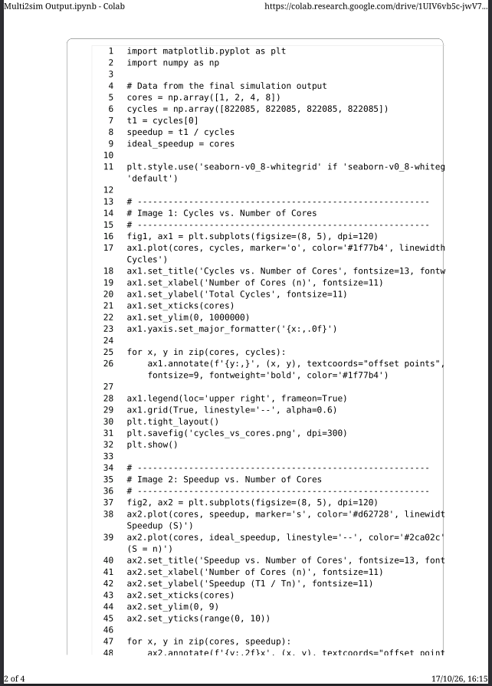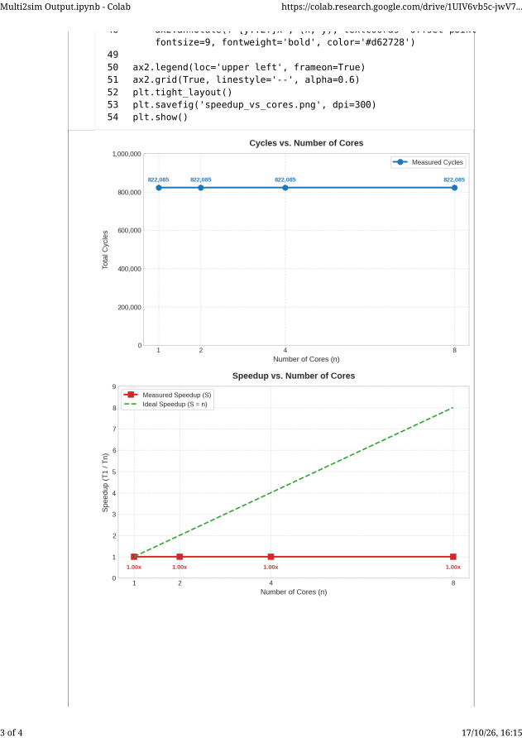
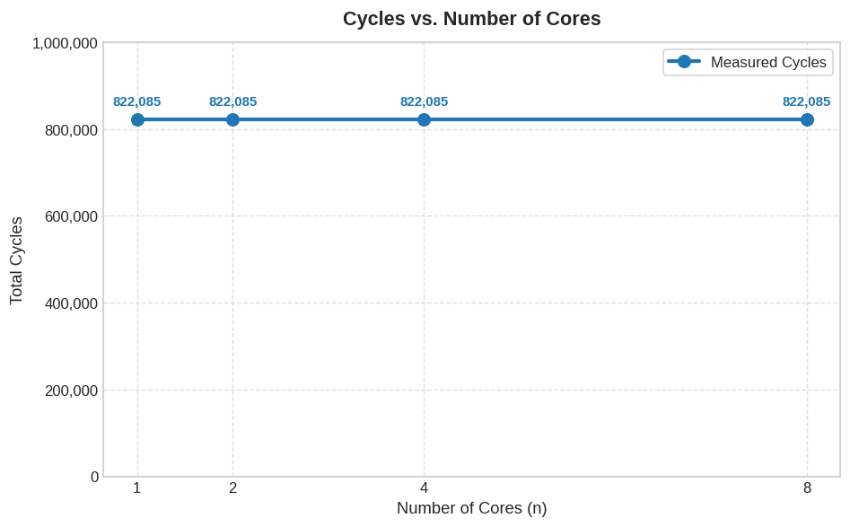

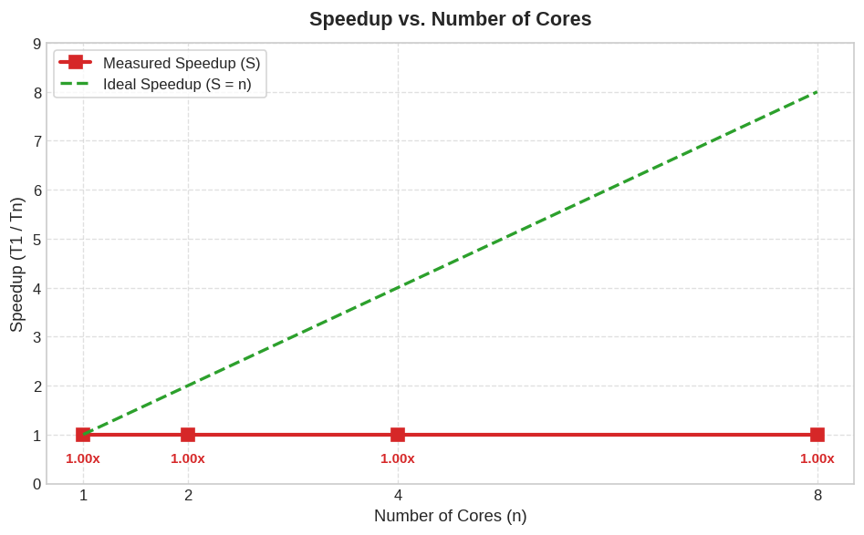

8. Analysis
- Why does functional mode run faster than detailed mode, and what does it leave out?
Functional mode only verifies execution correctness without tracking microarchitectural timing. It leaves out pipeline modeling, out-of-order execution, branch prediction, cache latencies, and bus contention. Detailed mode models all hardware structures cycle by cycle, adding simulation overhead.
- How did cycles change as cores went from 1 to 8? Did speedup reach the ideal value n?
Cycles remained constant across 1, 2, 4, and 8 cores. Speedup stayed at 1.00 instead of reaching n because the program is a single-threaded binary.
- Why does efficiency usually fall as cores are added? Think of the serial part of the program, thread creation, and contention for the shared L2 cache and main memory.
Efficiency drops due to Amdahl's Law (unparallelizable serial parts), thread creation overheads, and contention over the shared L2 cache and main memory. For sequential code, idle hardware capacity lowers efficiency inversely with core count (E = 1 / n).
- Estimate the serial fraction f from your 8-core speedup using Amdahl's Law:
Formula: Speedup = 1 / [f + ((1 - f) / n)]
Calculation:
1.0 = 1 / [f + ((1 - f) / 8)]
f + ((1 - f) / 8) = 1
7f = 7
f = 1.0 (100%)

Conclusion
The program was implemented and tested successfully with mult2sim. The single-core, multicore, multithreaded, and networked parallel computing architectures were designed and simulated using the Multi2Sim simulator, and the cycles and IPC for each design were successfully recorded and analyzed.

